SPOT reflection:
Together with Gwen Klerks and Martine Bak I chose to create an interactive Spotify playing interface. This became SPOT. SPOT is a minimalistic looking device that consists out of a round base with a rotatable lever with a single knob. The lever features a display showing the current song playing. A user bas
Our main goal was that it had to be intuitive, a user should understand how to use this design on first notice. We limited ourselves in using aesthetic interactions. This led us to designing a very physical interaction Intuitive interactions were: Turning on/off (by flipping over the lever to show the knob and display), Changing volume (by turning the only know on the device), Browsing playlists (by turning the lever left and right) and skipping songs (by adjusting the height of the lever, which slowly drops down during a playlist).
However the way playlists were organised did call for an aesthetic interaction. We decided to put energetic music to the right and relaxing music to the left which does require some knowledge that isn’t inherently intuitive.
Our Design proposition relates to the frogger framework. We tried to combine feedforward and feedback in such a way that our product conveys “This is a music player and this is how I use it”.
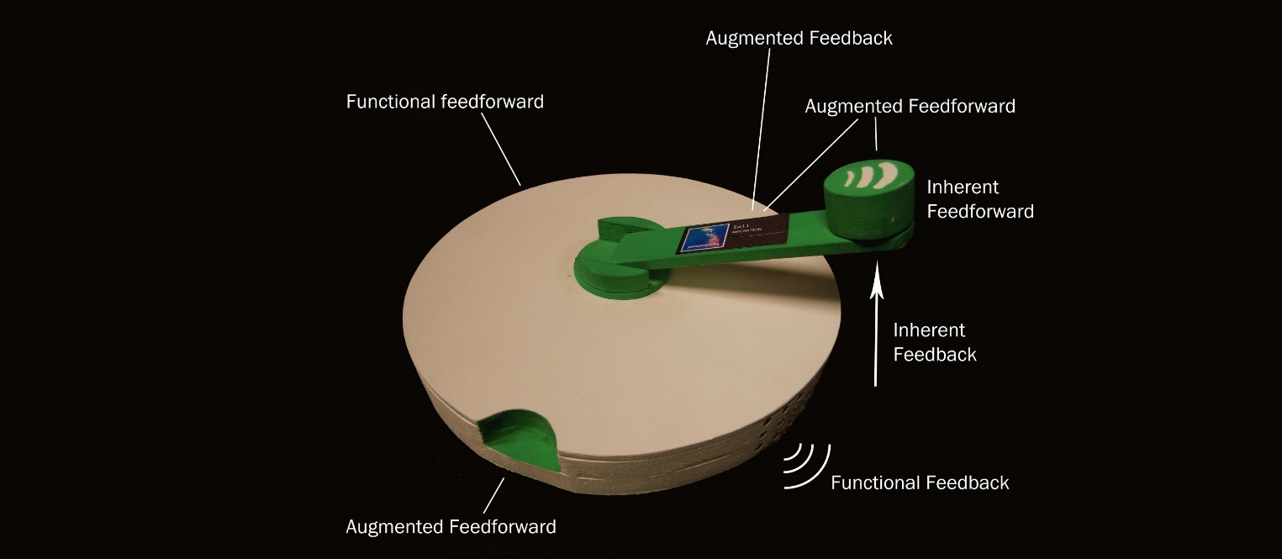
Above is an overview of feedback and feedforward in SPOT. SPOT looks like a record player and has very obvious speaker holes conveying it is a music player. The lever nearly screams to be lifted, and reveals the other functions SPOT offers when it is brought to an “on” state.
To enrich the interaction SPOT offers we made a point of coupling the action to the function. This, in my opinion, calls for a physical interaction, as it allows a user to use all senses to interact instead of only the audio-visual. I describe the coupling of SPOT as it is described in the paper “Interaction Frogger: A Design Framework to Couple Action and Function through Feedback and Feedforward”:
Time: Most of the functions of Spot are not available before it is turned on. And it allows the user to set the playtime and playlist in one movement.
Location: All controls are located in a way that allows the user to control all aspects of the device in one place. But they do allow for manipulation in other places on the lever.
Direction: When holding the volume knob, a user can twist the knob, twist the handle and lower or raise the handle. All actions have a different function
Modality: Most feedback of SPOT is audio based, because it is an audio based product. Though position of the lever and the display also offer very important visual feedback.
Dynamics: SPOT offers a user to quickly start playing, which allows for less accuracy and more of a surprise in what is going to come. But it also allows a user who has more time to choose songs more concretely.
Expression: SPOT does not offer very much feedback on expression. Though the lever does call for expressive input (hit it hard, spin it fast etc.) I think improvements could be made on this specific point, to establish a emotional bond between product and user.

Personal Reflection:

I think DG622 is a massively useful assignment, the principles of it could be relevant for any ID project, but moreover, for any consumer product. In a world where interaction richness has been seeing a decrease, I think it could be very important and valuable to look back at what made mechanical products not require a manual. Using these principles, together with today’s knowledge and research can contribute enormously to any new product brought to the market.
This assignment made me realise, once more, how important it is to thoroughly consider the interaction a user has with a product. Then the assignment gave me the tools to deal with it, can safely say that the Frogger framework and some of the other papers presented in this assignment will be making appearances in future projects and research of mine. I have started looking at objects I use every day as subjects of this assignment, this really gives insight into how products have come to a certain size, have specific colors, etc.
While user interaction can seem like a very abstract I now feel like I can have a structured approach to dealing with it. Trying things out of course remains the most important way in testing if a product will work, but using tools such as the frogger framerwork, or considering richness of interactions in a near mathematical way can give very good and valuable direction to a project or product.
DG622 could be invaluable for any designer or maker. While content might seem a bit dry, even the smallest of interest in interaction design can make up for it (my interest certainly did, I looked forward to each meeting). My only gripe is that not all first year students are being introduced to ID with this information.

